Database Technologies – Assignment 7 Optional

Note: To solve below queries, use “hr” database
- Display department name and manager first name.

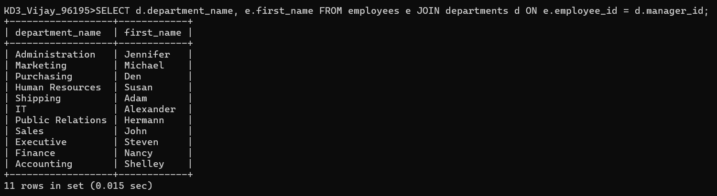

- Display department name, manager name, and city.

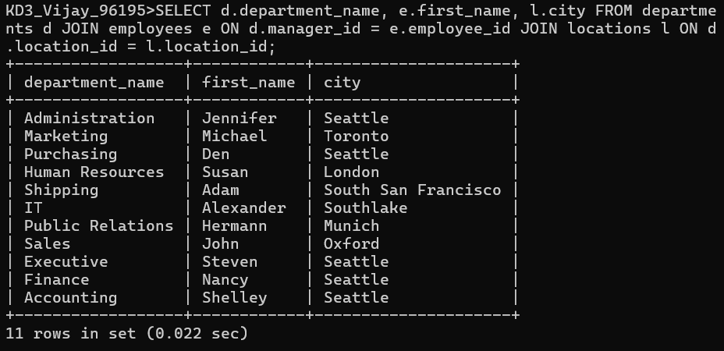

- Display country name, city, and department name.

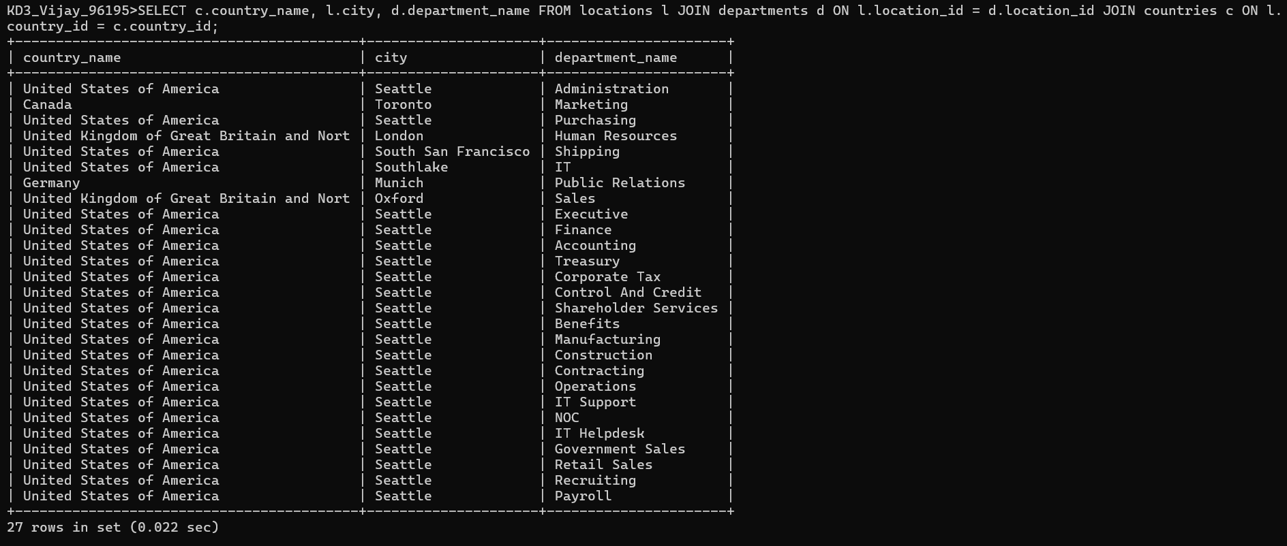

- Display job title, department name, employee last name, starting date for all jobs from 2011 to 2015.

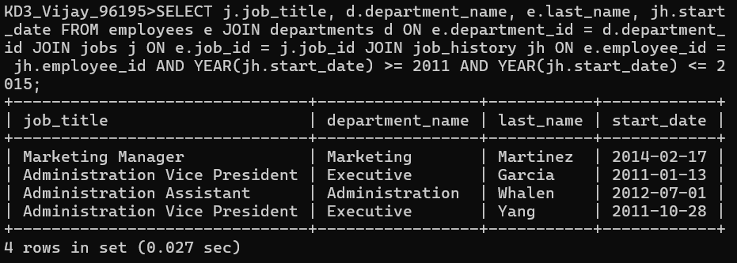

- Display job title and average salary of employees.

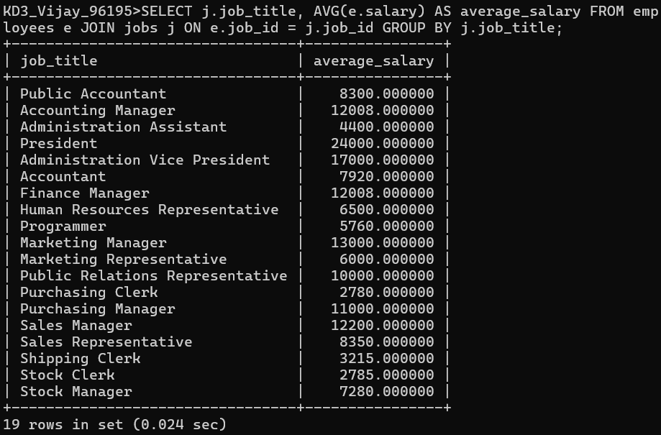

- Display job title, employee name, and the difference between maximum salary for that job and salary of the employee.

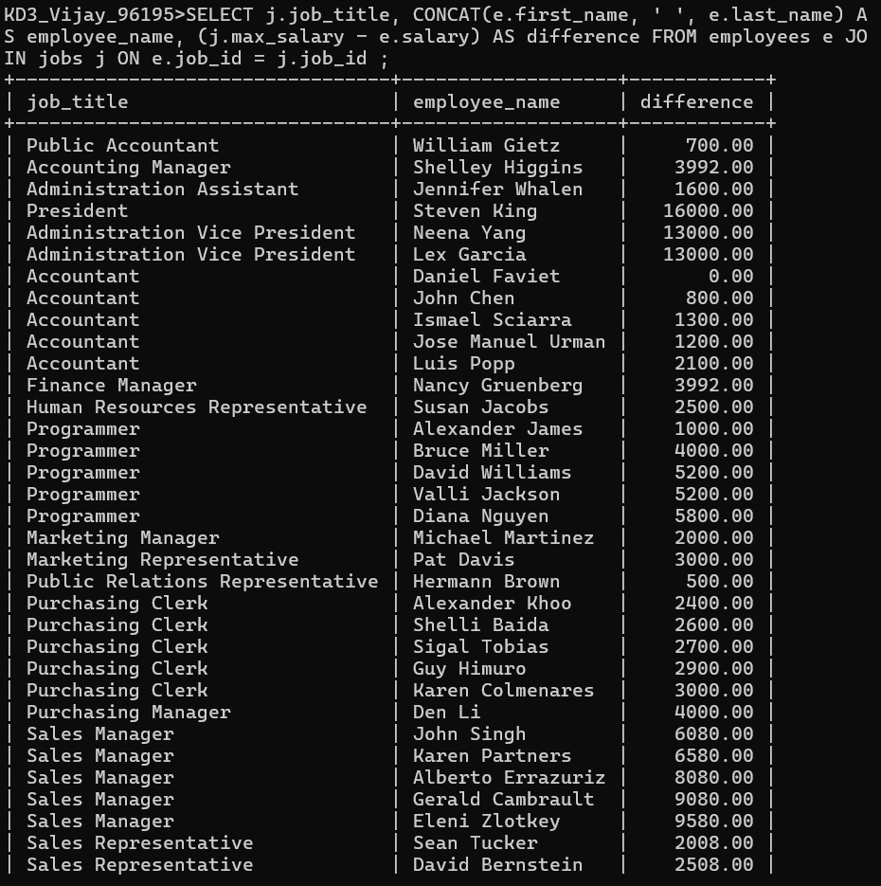
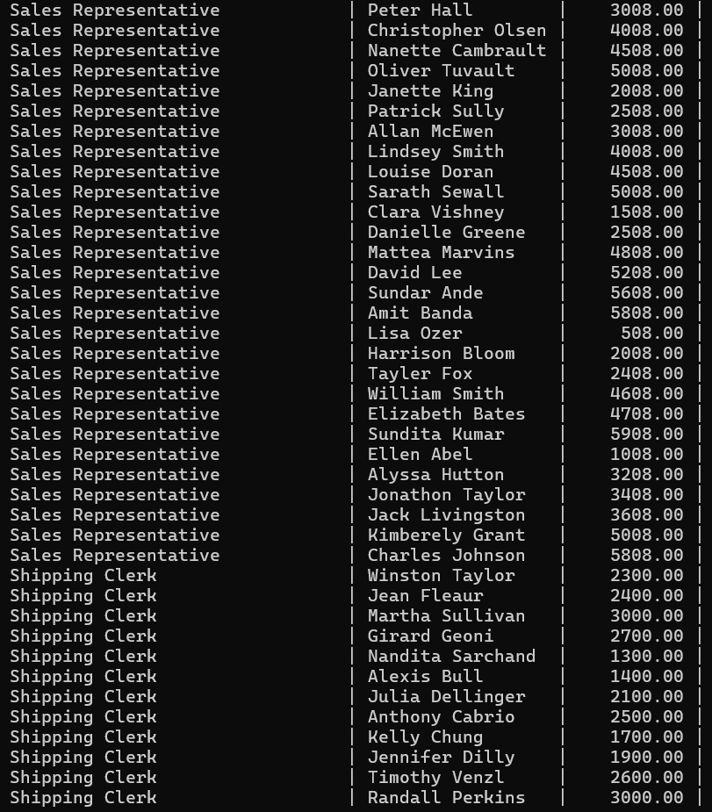
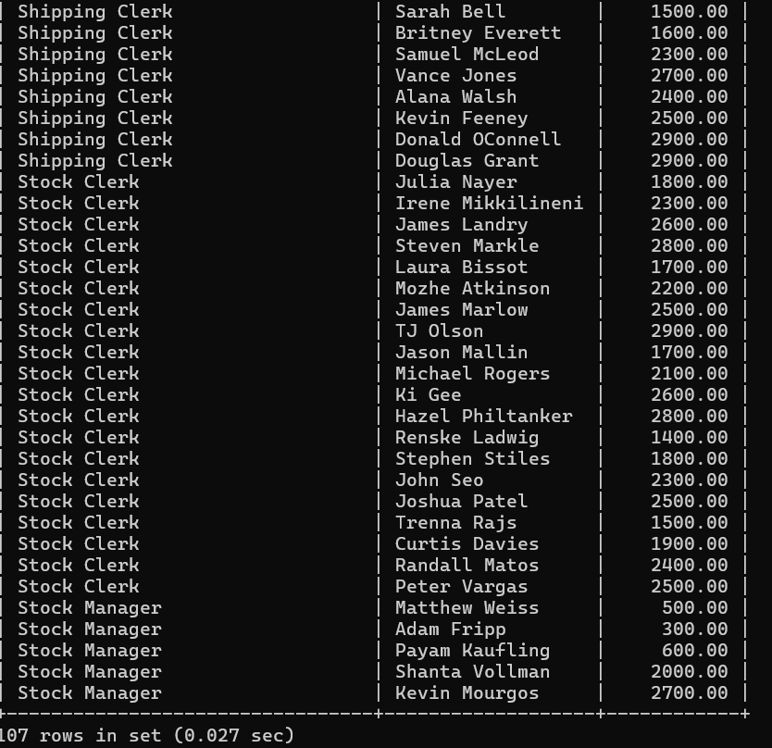

- Display the last name and job title of employees who earn a commission but do not belong to any department.

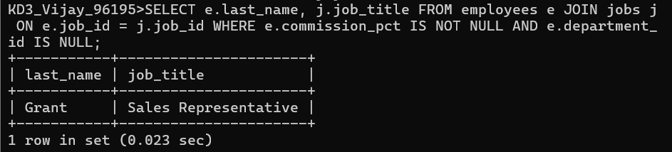

- Display details of jobs that were done by any employee who is currently drawing more than 15000 of salary.

